Advisory report
International Facility Management, Hanze

January 16, 2026

Emma van der Hoofd
Emilia Hansen
Joshua Gabriel
Marit Oorburg
Roos van der Weij
Stella Marban

Advisory report
International Facility Management, Hanze, Groningen

(IFVP23PRJ2) Project Service Design & User Experience 2, Maris Boeringa, Pauline Harmsen, Ruud de Lange

Emilia Hansen, eih.hansen@st.hanze.nl (501693)
Emma van der Hoofd, ec.van.der.hoofd@st.hanze.nl (500438)
Joshua Gabriel Belong Suva, j.g.b.suva@st.hanze.nl (458466)
Marit Oorburg m.oorburg@st.hanze.nl (503992)
Roos van der Weij, r.e.van.der.weij@st.hanze.nl (462652)
Stella Marban sl.marban@st.hanze.nl (480852)

January 16, 2026
Groningen

Number of words: 3868

Preface
This advisory report was developed as part of the Project Service Design & User Experience 2 course within the International Facility Management programme at Hanze University of Applied Sciences. The report, prepared by Emma van der Hoofd, Emilia Hansen, Joshua Gabriel Belong Suva, Marit Oorburg, Roos van der Weij, and Stella Marban, focuses on analysing the current event management process at the Wiebenga building in Groningen and identifying opportunities for improvement.
This project was initiated in response to observed inconsistencies between the event management process at the Wiebenga building and the more standardised procedures that were implemented at other Hanze locations, such as the Zernike campus. These differences have led to inefficiencies in event processes, increased staff workload, and varied experiences for both event organisers and visitors. At the request of Ruud de Lange, location manager within the Facility Management Department, this research was aimed to identify bottlenecks in the current process and to develop practical recommendations for aligning the Wiebenga building’s event management with campus-wide standards.
To gain a comprehensive understanding of the current event situation at Wiebenga, both qualitative and quantitative research methods were utilised. The research process included conducting interviews with the event management staff, making observations during a graduation event at Wiebenga, and distributing a survey among event attendees. By combining these methods, it was possible to collect in-depth information on organisational challenges as well as measurable data on user experiences.
The project group would like to express its gratitude to Ruud de Lange for his guidance and input throughout the project. In addition, special thanks are extended to Monique Nahumury-Zuidema and other staff members at the Wiebenga building for their cooperation and willingness to share their knowledge and experiences. Finally, the group would like to thank the course lecturers, Maris Boeringa, Pauline Harmsen, and Ruud de Lange, for their supervision, support, and assistance throughout the project.
Management Summary
The advisory report examined the event management process at the Wiebenga camo. The research was initiated due to inconsistencies between the event management process at Wiebenga and the more centralised system on the Zernike campus. These inconsistencies resulted in inefficiencies, increased staff workload, and differences in user experience. Practical issues identified included fragmented event requests, limited parking, accessibility challenges, and unclear wayfinding. Based on this context, the main research question was: What needed to change to streamline the event management process at Wiebenga to be more aligned with the campus event organisation?
A mixed-method research approach was used to obtain a reliable, comprehensive view of the event management process at Wiebenga. Data collection included interviews with the location manager and an event organiser, a survey distributed to event attendees, and direct observation during a graduation event. The combination of methods enabled the collection of both organisational and user perspectives. The research focused on event organisers, staff, students, and external users as the main target groups. By integrating qualitative and quantitative data, the study compared user experiences with identified organisational challenges.
The research findings showed that the event management process at Wiebenga was decentralised, relying on manual coordination and direct communication between stakeholders. Event requests were managed through several contact points, which reduced transparency and contributed to a higher staff workload. Both observations and interviews identified recurring issues, including limited parking, insufficient waste disposal, barriers to accessibility for visitors with disabilities, and unclear wayfinding. Survey responses reflected a range of experiences, with some users reporting positive outcomes regarding parking and accessibility, indicating that these challenges were not experienced equally by all groups. In contrast to other Hanze locations, Wiebenga did not utilise a central system such as TOPdesk for event requests and evaluations, which limited opportunities for standardisation and oversight.
In conclusion, the findings indicated that both organisational and practical improvements were necessary to streamline the event management process at Wiebenga. Implementing TOPdesk as a single-entry point for all event requests was recommended to improve efficiency, transparency, and alignment with all campus event standards. Additional recommendations included providing clearer communication about parking options, enhancing signage and wayfinding, offering better accessibility information, and introducing event-based waste management to improve the overall visitor experience.
Implementing these recommendations was expected to lead to a more consistent and professional event management process at Wiebenga. The consequences of the recommendations included reduced administrative workload for staff, clearer expectations for event organisers, and a more inclusive experience for visitors.

Table of contents
4. Results 1
4.3 Results and analysis sub-question 3 3
4.4 Results and analysis sub-question 4 4
4.4.1 Guest Experience 4
4.4.2 Event Requester Experience 5
5. Conclusion 6
6. Discussion 7
6.1 Assessment of reliability 7
6.2 Assessment of validity 7
6.3 Follow-up research 8
7. Recommendations 9
7.1 Recommendations 9
7.2 Consequences 11
Literature list 13
Appendices 14
Appendix A 14
Appendix B 17
Appendix C 18
Appendix D 21
Appendix E 28
Appendix F 29

4. Results
This section presents the results and detailed analysis from investigating the event management process at the Wiebenga building, in comparison with the campus organization. Our findings are structured to directly address the main research question: What needs to change to streamline the event management process at Wiebenga to be more aligned with the campus event organisation? This question is the structure of our research, which was broken down into four sub-questions:
- What is the current event process in Wiebenga?
- What type of bottlenecks are the most common?
- What are the differences between event management on campus and Wiebenga?
- What can be done to improve user experience?
The analysis uses data gathered from multiple methods, including an initial interview with Ruud de Lange, a follow-up interview with Monique, direct observation during a graduation event at Wiebenga, and feedback collected through a user survey.

4.1 Results and analysis sub-question 1
What is the current event process at Wiebenga?
This first sub question takes you through the event management process at Wiebenga. To get all the information that we needed, the group used two methods. An interview with Monique that has insight in the event management at Wiebenga, and a survey that gives us insights from the user’s perspective.

After interviewing Monique, a clear overview was gained over what happens at Wiebenga when an event request comes in.

Event requests for the canteen are made at the service point desk. Other rooms are handled by the planning desk. When the event is confirmed, you must fill out a form on the Hanze website, and top desk processes your form. The organiser of the event handles the different requests like decorations, catering, etc. There is then a follow up meeting to discuss details of the event.

After all requirements are settled and agreed on, other providers are informed about what is going to happen step by step. The final agreement gets printed and left at service point on the day of the event. The day of the event is about preparations of the rooms, the food and beverages and last-minute adjustments.
To make sure that everything gets done correctly, every team member has their own defined responsibilities. There is a checklist that is followed by team members. Wiebenga has contracts with main suppliers, such as Eurest for catering and MASH for flowers. They also have other suppliers for variation, but as stated these are the main ones. Balloons are organised through external suppliers.

This is the information that was collected at the interview with Moniqe, and it gives an overview over the current process.

4.2 Results and analysis sub-question 2
What type of bottle necks are the most common?
The second sub-question identifies the most significant bottlenecks experienced at Wiebenga. This analysis is based on the group’s observations after attending an event at Wiebenga. Observations at an event at Wiebenga showed that the main problems were related to facilities and managing how visitors moved through space. One clear issue was not having enough waste bins, which caused bins to be hard to find and trash to be set down. This could affect both user experience and safety. Many attendees at the event also seemed unsure where they were supposed to go, which indicated that the signs and directions were not clear enough for the users.
Accessibility was another problem, as the venue was not easy for people with disabilities to navigate and prevented some users from being able to attend parts of the event. This limited their mobility and did not meet best practices for making events inclusive and accessible. There were also not enough parking spaces, which led to traffic jams and delays before and during the event. These findings match what event management literature says: problems with facilities and logistics, like waste management, accessibility, and parking, are common at events. The issues seen at Wiebenga support the idea that infrastructure and organization are key factors that affect how smoothly an event runs and how satisfied visitors are.
The survey results provided a clear picture of how users personally experienced bottlenecks at the Wiebenga event. Most people rated parking as okay (38%) or particularly good (29%), while a smaller group found it poor (19%) or terrible (7%). This showed that parking was a bottleneck that some users experienced, but not everyone had difficulties due to public transport or biking, which pointed to capacity problems at the event rather than a complete failure in parking management. In contrast, accessibility got more positive ratings in the survey, with 48% saying the event was accessible, 19% saying it was not, and 26% saying maybe.
Comparing the survey results to the observations that were made showed a clear difference. Observations found accessibility to be a major bottleneck due to the limited handicap-accessible infrastructure and outdated building, but survey responses were more mixed and more positive, because not all visitors needed accessible facilities. Parking issues were also more obvious in the observations because of visible congestion, while survey results showed a range of experiences. The comparison between survey results and observations showed that observations tend to reveal structural and organizational bottlenecks, while surveys reflect personal views that might downplay problems that affect only certain groups of visitors.
The interview with the event manager at Wiebenga provided deeper insight into the bottlenecks the organization had experienced from a practical standpoint. One of the main challenges discussed was the limited parking capacity, with only 10 spaces available to reserve for the entire building. Most guests, therefore, had to use paid parking in the city, which was communicated in advance. In some cases, the school can issue parking tickets to visitors. Special parking arrangements were made for people with disabilities or select employees, depending on need and availability, but these options remained limited.
Limited space availability was another recurring difficulty. Only a few large rooms could be used for events, and when multiple events took place at the same time, this often led to complex logistical planning. Smaller rooms could not be combined into larger spaces because lessons were ongoing, and the annual schedule was already fully booked. In addition, there was no option to set up outdoor tents when extra space was required or when weather conditions were unfavourable. Noise had also been an issue in the past due to the old building structure and overlapping events with examinations, although this problem had become less significant after exams were scheduled separately.
Comparing the interview results with the observations and survey data and results revealed both similarities and differences. The event manager’s main concerns about parking shortages and limited space resembled the difficulties and issues that were observed. However, the responses from the survey indicated that the users perceived these challenges less negatively, particularly regarding parking and accessibility. This concluded that the organisational bottlenecks are more apparent to the event managers, while attendees focus on issues that directly affect their experience. Combining interviews, observations, and survey results provides a more comprehensive understanding of the main challenges at Wiebenga events.

4.3 Results and analysis sub-question 3
What are the differences between event management on campus and Wiebenga?
For this third sub-question, the group also used the method of observation. First, during graduation at the Wiebenga building, a few aspects were noticed. As discussed in the second sub-question, the bottlenecks at Wiebenga became significantly clearer.
Before visiting the Wiebenga building however, an interview with Ruud de Lange was organised. On Friday the 26th of September, the group got the chance to ask a view of questions about Ruud’s objective regarding the project and the current event process at the different Hanze buildings. Ruud explained some about the event process on campus and how this was desired for all Hanze buildings.
Mentioned was a method of organising an event. On campus, this happens through the Event Management Office. Used on campus is TOPdesk, a central system for facility service requests. Some buildings outside the campus do not or barely use this application. So, where on campus this is also used for evaluations, in other buildings this gets done informally.
Yet this interview was conducted before the formulation of the sub-questions. Because more information was needed, another interview was held with Monique Nahumury-Zuidema. With that interview, more detailed information was revealed as described in the results for the first sub-question.
The differences between the event management on campus and Wiebenga are now detectable. On campus, the method of organising an event happens through the Event Management Office whereas at Wiebenga the event organisation goes independently. Requests for the serre or canteen are first made at the service point desk.
Another significant difference between the Wiebenga and campus the way of evaluation after an event has been organised. The evaluation on campus goes through TOPdesk, whereas at Wiebenga they do not make use of this at all. The evaluation here goes informally.
Additionally, as already mentioned under sub-question 2, are the bottlenecks for the Wiebenga building. These mostly relate to the state of the building. Mentioned during the interview is that the building is quite old. It is compared to those on campus smaller, less accessible, and has poor sound insulation. These issues do not occur on campus.
Written above is the answer to the third sub-question. It shows how event management at Wiebenga differs from that on campus. A way can be found on how to streamline the event process on the Hanze buildings, which is important for a better user experience.

4.4 Results and analysis sub-question 4
What can be done to improve user experience?
To answer sub-question 4, a combination of survey results, interviews, and observations was used. As each method supports the others, their combination provides a comprehensive understanding of the current event management in Wiebenga, which makes the identification of both the strengths and improvement points of the event management process.

4.4.1 Guest Experience
The survey results show that the event experience has received a mixed rating of 3.8 out of 5. Although the event itself has been rated positively as guests' expectations were mostly met and effective communication, the user frustration lies in logistical issues as well as accessibility.
The question on parking experience received 16 neutral and 11 negative responses. This highlights the fact that the experience could be improved.

There are few accessible parking spaces nearby Wiebenga. However, there is a parking garage close by, but most visitors do not know about it. A solution is to include a map in the event invitation that highlights nearby parking spaces and garages.

As for the accessibility issues, we have two specific responses. One states that it depends on which entrance is used, and the other states that it is hard to find their way as well as the elevators. This issue could be addressed by placing clear directional signs, elevator locations, and marking accessible entrances.

4.4.2 Event Requester Experience
The current process for event organisers at the Wiebenga building is decentralized and highly dependent on interpersonal coordination. Thus, it is heavily reliant on meetings and manual coordination, which means that it is time-intensive and depends heavily on individual staff members.
Wiebenga’s strong point is that the staff is actively engaged in every step of the event planning, providing knowledge and insight. This approach assists in managing the limited resources and space of Wiebenga.
However, there are points that should be improved to elevate efficiency, such as streamlining communication by using TOPdesk, which also eliminates the need for two contact points whether the requester needs the space in the canteen and serre or for other rooms.
Additionally, using TOPdesk makes the event planning comply with the standard of the other Hanze locations, leading to a more centralized and streamlined event planning process. An improvement point for TOPdesk could be that it should be able to display the availability of a space for the requester. This will allow for better scheduling and will reduce the workload of event organizers by eliminating the need to schedule them manually.
Furthermore, open communication through each department should allow for a reduced number of meetings. Meetings should only be held when necessary: at the start of planning to discuss resource availability and just before the event to confirm that everything is in order.
In conclusion, the attendees’ experience can be improved through better information about parking spaces and guidelines for accessible routes. Additionally, the event requesters’ experience can be refined by streamlining the processes and eliminating redundancies.

5. Conclusion
In this report, there was research done to answer the main question: What needs to change to streamline the event management process at Wiebenga to be more aligned with the campus event organisation?
When looking at the interview with Monique, it became clear that there is not one way of organising an event at Wiebenga. This gives the employees more workload and there is less overview. From the survey it became clear that attendees did not always find the building accessible. This also came up when the group did an observation at the Wiebenga building. Overall, the responses to the survey were positive, but another point of attention is the parking situation. There were some attendees who did not have a pleasant experience with parking. To streamline the process with that of the campus, it is necessary that all the different events can be organised in one place.

6. Discussion
This chapter indicates reliability and validity on the gathering of information for this advisory report. A critical look is given on the outcome and the vision beforehand. Additionally, written is where actions could have been done differently and how this would have improved the result.
Lastly, some topics could not be answered with the research that is done. These are discussed and given as interesting for our client, Ruud de Lange, to research next time.

6.1 Assessment of reliability
The reliability of this research was supported using structured methods. All interview participants were asked the same set of predetermined questions, and the same survey was distributed to all respondents. This approach followed the original research plan, which aimed for standardisation to achieve repeatable results. Interview and survey questions were tested in advance, which helped clarify any unclear wording and led to more consistent data collection. Notes and audio recordings were made during interviews to reduce the risk of misinterpretation or missing information. However, some aspects did not proceed as planned and may have affected reliability. The research plan included two interviews, but the first interview with Ruud was conducted before the sub-questions were finalised. As a result, the questions were not fully aligned with the research focus, which limited comparability between interviews. The survey received a small number of responses, which reduces the stability of the results and increases sensitivity to individual differences. Observations were carried out during only one event, so the findings may not represent all events at Wiebenga. These deviations from the planned approach introduce limitations and reduce the overall reliability of the research, as repeating the study under the same conditions might not produce identical results.

6.2 Assessment of validity
The validity of the research was supported by a clear alignment between the research questions, the selected methods, and the data collected. The research plan specified that all instruments, including interviews, surveys, observations, and the event request analysis, would be designed to directly address the four sub-questions. This approach was implemented as intended. Interview questions were developed to focus on the event process, identify bottlenecks, and highlight differences between locations, ensuring that the data collected corresponded to the variables under investigation. Survey questions were constructed to measure user experience, accessibility, parking, communication, and expectations, in line with the research objectives. Observations conducted during the graduation event provided direct evidence of logistical and structural issues, which enabled comparison between user perceptions and actual conditions. By applying multiple methods to examine the same themes, the research achieved triangulation, thereby increasing the reliability and comprehensiveness of the findings regarding the event experience at Wiebenga.
However, several aspects did not go as planned and may have reduced validity. The research plan stated that interviews would be conducted after the sub questions were fully developed, but the first interview with Ruud took place earlier, meaning the questions were not yet aligned with the final research focus. As a result, some of the information collected was broader than needed and not always directly connected to the variables being measured. Additionally, the survey relied heavily on self-reported experiences, which can introduce bias—especially because many respondents did not personally require accessible facilities, leading to more positive accessibility ratings than the observations suggested. The research also depended on a single observed event, which limits the extent to which the findings represent all events at Wiebenga. Finally, the planned event request analysis was not executed as thoroughly as described in the research plan, which reduced the depth of insight into administrative bottlenecks. These deviations from the original plan reduce the overall validity, as the results may not fully capture the complete range of experiences or accurately reflect all aspects of the event management process.

6.3 Follow-up research
The research for this report focuses on the experiences of visitors and the structural bottlenecks of the Wiebenga building, which means several relevant aspects are unexplored. Important gaps include a more systematic investigation of bottlenecks from the organiser’s perspective, such as their workload, time spent on coordination, and how the current process affects stress, errors, and efficiency. In addition, this report does not explore how different stakeholders, service point staff, planning desk, suppliers, and campus Event Management Office may have conflicting perspectives on the same process. Finally, the research does not analyse event performance using indicators, such as processing times, number of requests, or frequency of last-minute changes, which could provide a more objective view of how streamlined the event management process at Wiebenga currently is. These could be interesting topics for a client to research another time.

7. Recommendations
This chapter provides an overview of all issues Wiebenga deals with and their solutions on aligning their event management process to that on campus. Also discussed are the consequences that come with implementing this advice on the current processes.

7.1 Recommendations
This section includes solutions for the problems and bottlenecks of events and the event process at Wiebenga, including the recommendations.
1. Decentralized and inefficient event request process
Problem:
Event requests are divided across the service point desk, planning desk, and separate forms. This creates confusion, duplication of work, and dependence on personal communication.
Solution:
Implement TOPdesk as the single-entry point for all event requests at Wiebenga, regardless of room type.
Create a standardized event request form in TOPdesk, including; type of event, expected number of visitors, required facilities (catering, AV, decoration, accessibility needs), assign one internal coordinator to monitor and route requests within TOPdesk.

2. Limited Visibility of Room Availability
Problem:
Event organizers cannot see which spaces are available, leading to time-consuming coordination and unnecessary meetings.
Solution:
Integrate a basic room availability overview into TOPdesk.
Use standardized time slots instead of full scheduling flexibility to match Wiebenga’s limited capacity.
Clearly block periods reserved for education and exams.

3. Parking Capacity and Visitor Confusion
Problem:
Only ten parking spaces are available, causing congestion and frustration. Many visitors are unaware of nearby parking garages.
Solution:
Include a parking information page in the event confirmation email, containing; a simple map with nearby parking garages, public transport and bicycle options, clear explanation that on-site parking is limited, reserve on-site parking only for: people with disabilities, essential staff, or speakers. Letting visitors arrive in different time slots can help reduce traffic as well and make parking easier.

4. Accessibility Limitations Due to Building Structure
Problem:
The outdated building limits mobility for visitors with disabilities, and accessible routes are unclear.
Solution:
Place clear, visible signage for; accessible entrances, elevators, accessible toilets
Add accessibility information to event invitations, explaining which entrance to use, where assistance is available, assign a staff member as accessibility contact during larger events.

5. Wayfinding and Visitor Flow Issues
Problem:
Visitors are unsure on where to go, causing crowding and inefficiency during events.
Solution:
Use temporary event signage (roll-up banners or standing signs) on event days.
Mark routes from entrances to event spaces clearly.
Include a simple floor map in the event of communication.

6. Waste Management During Events
Problem:
Insufficient waste bins lead to litter and reduced cleanliness.
Solution:
Use an event-based waste plan, where extra bins are placed temporarily for larger events.
Assign responsibility for bin placement to one team member using a checklist.
Coordinate with cleaning staff before and after events.

7. High Dependence on Meetings and Manual Coordination
Problem:
Event planning relies heavily on meetings and individual staff knowledge.
Solution:
Use TOPdesk to centralize communication and documentation.
Limit meetings to; one initial coordination meeting (only for complex events), one final confirmation check, store standard procedures, checklists, and supplier contacts in TOPdesk.

7.2 Consequences
Implementing the proposed solutions is expected to have a positive impact on both the efficiency of the event management process at the Wiebenga building and the overall customer satisfaction of event organizers and attendees. Managing event requests and room availability through TOPdesk would create a more structured and transparent workflow, reducing reliance on personal coordination, and lowering the risk of miscommunication. As a result, event organizers and students would experience a clearer, more standardized planning process, leading to less planning time and workload. By integrating a basic room-availability overview into TOPdesk, using standardized time slots, and blocking periods reserved for education and exams, event organizers can see which spaces are available and avoid unrealistic requests.
The introduction of standardized procedures, such as improved visibility of room availability and streamlined communication between departments, would improve coordination, and reduce unnecessary meetings. This would allow staff to plan their time more efficiently and focus on event quality instead of the administrative tasks. For event requesters, this translates into faster responses, clearer expectations, and a more professional service experience.
Solutions aimed at visitors, such as improved communication about parking options, clearer signage, time slots, and better wayfinding, would directly improve the arrival and on-site experience. By managing expectations regarding limited parking and providing clear directions to alternative parking facilities and accessible routes, visitor frustration and confusion would be decreased. Improved accessibility information and signage would increase inclusivity, enabling visitors with mobility limitations to participate more fully in events. Letting visitors arrive at various times makes parking easier and reduces traffic as well.
Using temporary signage, marking routes, and including a simple floor map helps visitors find their way easily, reduces confusion, and improves their overall event experience.
Operational improvements, including better waste management planning and clearer task assigning through checklists, would improve safety, cleanliness, and comfort during events. These improvements contribute to a more organized event environment, which positively influences visitors' view of quality and professionalism.
Overall, the combined effect of these solutions would lead to more consistent event execution, reduced stress for staff, and a smoother experience for visitors. This increased reliability and clarity in both the planning and execution phases are expected to improve customer satisfaction, strengthen trust in the event organization, and align the Wiebenga event management process better with campus standards.

Literature list
No external literature or sources were used in the preparation of this document. Therefore, a literature list is not applicable.

Appendices

Appendix A
Observation form

Sections | Criteria/Observation Area | Observed (Yes/No/Notes) | Examples/Details
Event Details | Event name/date/time/location | Graduation event, split shifts (1st: 14:30-15:30; 2nd: 16:30-17:30), Wiebenga (canteen to lecture halls) | First time on this side, normally end of year with more space.
 | Estimated attendees | Not specified; groups split due to space limits | Guests/students split into 2 shifts then subgroups for attention/attention span (max 1 hour).
First Impressions (Arrival) | Welcoming signage/greeting | Yes, Reusable balloon arch outside, clear door sign inside, big balloon arch with flowers. Greeted immediately, names marked on attendance list. | Tea/coffee with sweet treats provided. Positive mood.
 | Waste disposal availability | Not a lot of places for garbage disposal | Bins hard to find, trash set down on floors.
Starting Situation (Canteen) | Space usage/logistics | Limited space, Guests started in canteen, other students walked around. Area closed off (clear separation). | Decorated with flowers/balloons, big screens with graduating class name. Good/positive mood, but split groups affected atmosphere (staff/students disliked split). Moved to lecture halls after.
 | Refreshments | Yes | Tea/coffee + treats in canteen.
Main Situation (Lecture Halls) | Accessibility/handicap infrastructure | Elevator available, but no special wheelchair space | Weird/left out feeling for disabled, outdated building limits mobility.
 | Wayfinding/visitor flow | Poor, Vague upstairs, attendees guided but did not know where to go/stand, self-moved to halls | Tom held door, welcomed, asked if we were there for graduation (felt welcome). Crowding/confusion outside waiting/lecture areas.
 | Decor/space usage | Lovely, decorated halls (great atmosphere) no decor outside waiting/halls | Limited space for stuff/coats, no designated areas. Split shifts for personal attention but hurt flow.
 | Parking/arrival congestion | Visible congestion | More obvious in observation vs. surveys, limited spots caused issues.
Overall Environment | Temperature control | Not noted | positive
 | Waste management | Major issue, Insufficient bins | Overflow, litter reduced cleanliness.
 | General bottlenecks | Facilities/space management primary | Observations highlight logistics (flow, waste, parking, access) more than surveys (mixed/positive on access).

Appendix B
Interview questionnaire
-What does the typical process of organising an event at Wiebenga look like?
-What factors do you consider when planning an event at Wiebenga?
-What are the usual limitations you deal with while planning an event here?
-How do you deal with these limitations?
-What are the advantages of organising events in this building?
-What space do you typically use for events?
-How is communication between organisers of the events managed here?
-How is hospitality and catering for events managed?
-How is it evaluated if an event was successful or not?
-Do you have attendees or staff members give feedback? If yes, how do you make use of this?
-In what way do you consider sustainability in the organisation of events?
-Are you aware of any changes in trends or expectations regarding events? If so, what are they?
-What changes regarding the event process at Wiebenga have there been in the past years?
-What would you improve about the event process at Wiebenga?
-What do you think are the differences between the event management at Wiebenga and that at the campus?

Appendix C
Survey questions and response categories
- Have you ever attended an event at Wiebenga? (open days count as well)
  - Yes
  - No
  - Different option
- How was your parking experience?
  - Excellent
  - Very good
  - Okay
  - Poor
  - Terrible
- Where you able to find your way around easily?
  - Yes
  - No
  - Different option
- Do you think the event was handicap accessible?
  - Yes
  - No
  - Maybe
  - Different option
- How was the waste management?
  - Excellent
  - Very good
  - Okay
  - Poor
  - Terrible
- How welcome did you feel?
  - Excellent
  - Very good
  - Okay
  - Poor
  - terrible
- How did you learn about the event?
  - The website
  - A Hanze school
  - A high school
  - Parents
  - Friends
  - Different option
- How well did the event meet your expectations?
  - Extremely well
  - Well
  - Not well
  - Extremely not well
- How would you rate the event venue?
  - Excellent
  - Very good
  - Acceptable
  - Poor
  - terrible
- How informed did you feel before the event stared?
  - Very informed
  - Informed
  - A little informed
  - Not at all informed
- How well would you rate the communication with the organizers?
  - Extremely well
  - Well
  - Acceptable
  - Not well
  - Extremely not well
- How well would you rate the help of the staff?
  - Excellent
  - Very good
  - Okay
  - Poor
  - terrible
- How well do you think the event schedule was organised?
  - Excellent
  - Good
  - Okay
  - Poor
  - terrible
- Was the event duration appropriate?
  - Very appropriate
  - Appropriate
  - Inappropriate
  - Very inappropriate
- Where there any food or beverage available?
  - Yes
  - No
  - I don’t know
- If yes, how would you rate the quality and variety of the food and drinks available?
  - Excellent
  - Very good
  - Okay
  - Poor
  - terrible
- Did the event provide enough opportunities for social interaction?
  - Many opportunities
  - Some opportunities
  - Little opportunities
  - No opportunities
- What rate would you give the event?
  - One star
  - Two stars
  - Three stars
  - Four stars
  - Five stars
  - Six's stars
- Did you encounter any issues or challenges before, during or after the event? Please explain.
  - Enter your answer
- What do you think could be improved?
  - Enter your answer

Appendix D
All responses from survey respondents
1.Have you ever attended an event at Wiebenga? (open days count as well)
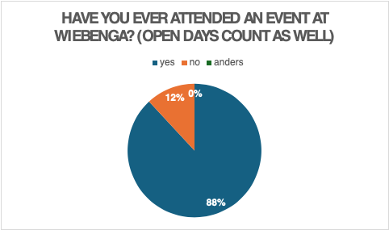

2. How was your parking experience?
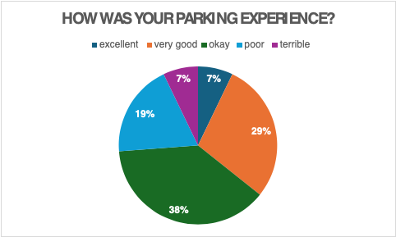

3.Where you able to find your way around easily?
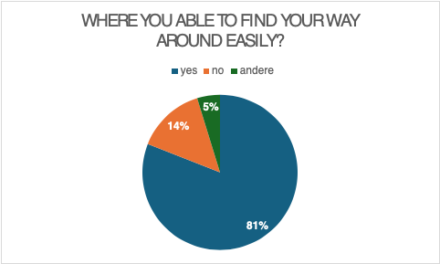

4.Do you think the event was handicap accessible?
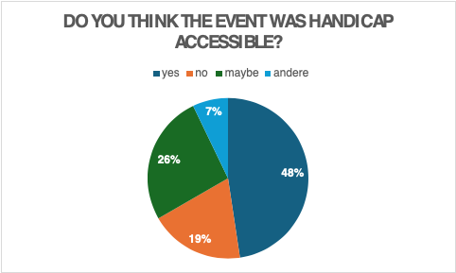

5.How was the waste management?
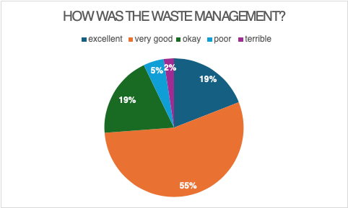

6.How welcome did you feel?
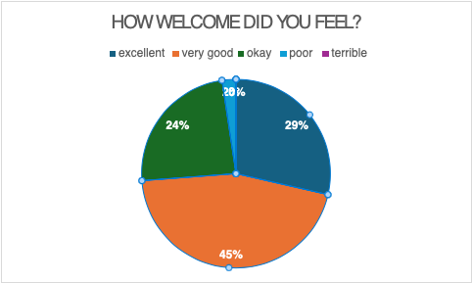

7.How did you learn about the event?
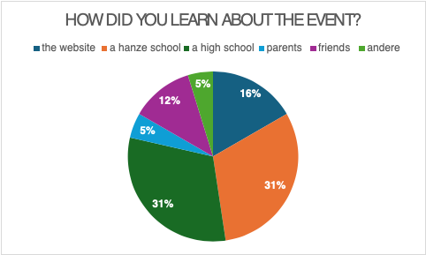

8.How well did the event meet your expectations?
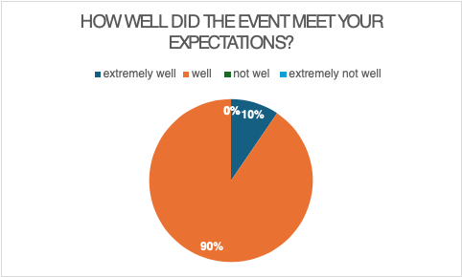

9.How would you rate the event venue?
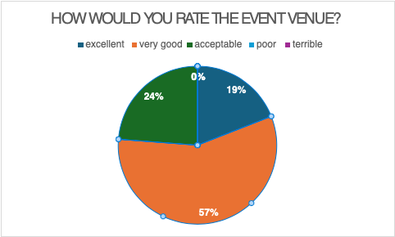

10.How informed did you feel before the event started?
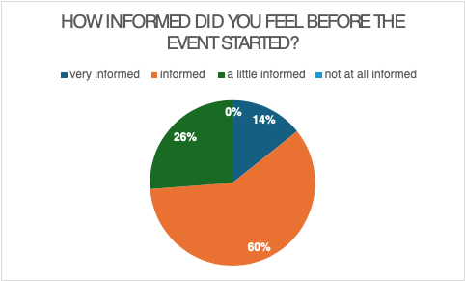

11.How well would you rate the communication with the organisers?
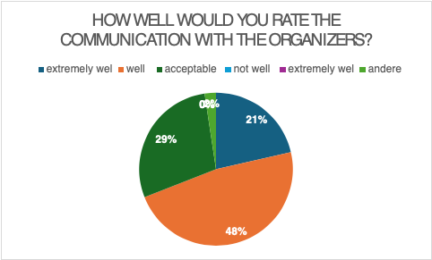

12.How well would you rate the help of the staff?
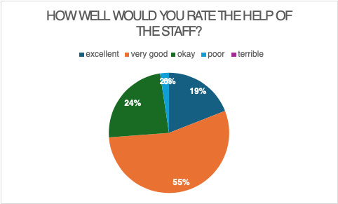

13.How well do you think the event schedule was organised?
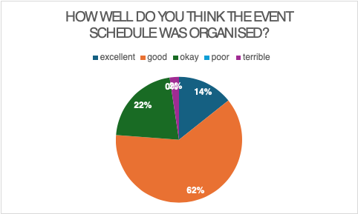

14.Was the event duration appropriate?
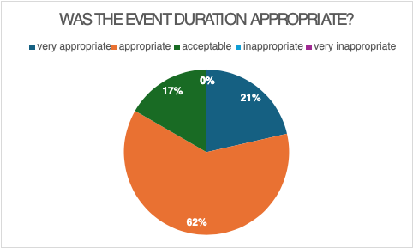

15.Where there any food or beverages available?
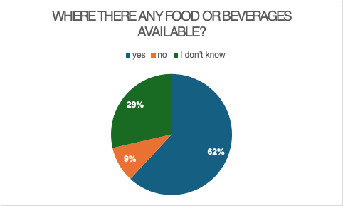

16.If yes, how would you rate the quality and variety of the food and drinks available?
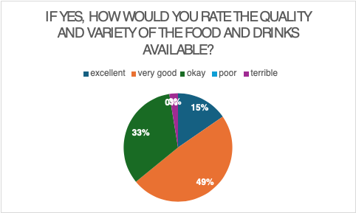

17.Did the event provide enough opportunities for social interaction?
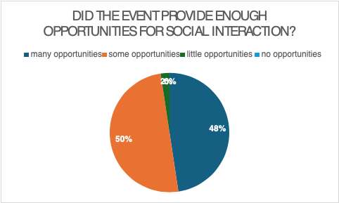

18.What rate would you give the event?
Six stars: 1
Five stars: 8
Four stars: 26
Three stars: 5
Two stars: 0
One star: 0

19.Did you encounter any issues or challenges before, during or after the event? Please explain.

(These are answers given by people who did encounter issues or challenges. Others have not filled this in.)
-Not sure on where to go
-Informed properly
20. What do you think could be improved?
(These are answers given by people who did think things could be improved. Others have not filled this in.)
-Times of events
-Let students have more say in the organising of events
-More clarity in organisation
-The way finding
-More people to guide on where to go
-Better guidance
-Better signs explaining where to go
-Parking
-Information before the event
-More info beforehand
-Duration
-A lot
-More trash cans
-The food

Appendix E
Service blueprint
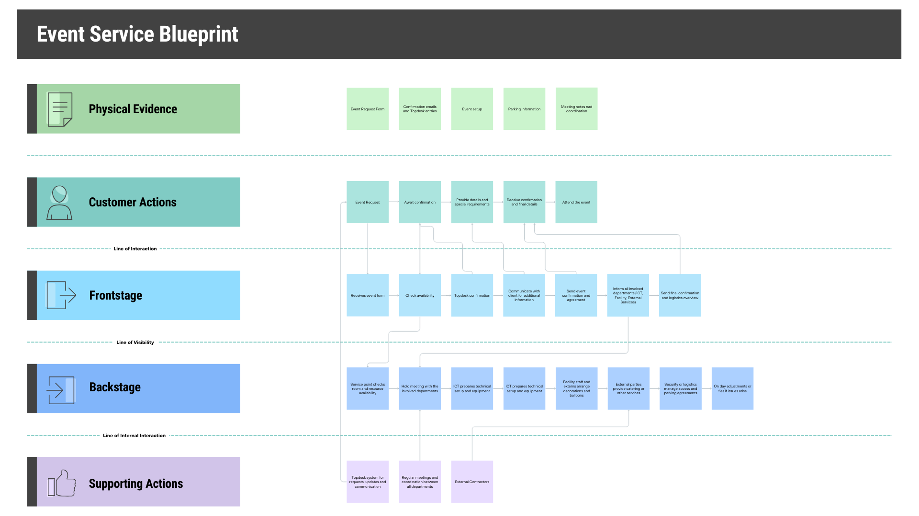

Appendix F
Executive summaries
Emma:
This project focused on the event management process at the Wiebenga building and identified ways to improve efficiency and user experience. The current process is fragmented, relies on manual coordination, and faces challenges with parking, accessibility, and wayfinding. Compared to campus buildings, Wiebenga lacks a centralized system like TOPdesk. We identified the main problems by combining data from surveys, interviews, and direct event observations
Proposed solutions include using TOPdesk, standardized time slots, clearer signage, better parking and accessibility information, and improved waste management. These changes are expected to streamline planning, reduce staff workload, and provide a smoother, more satisfying experience for visitors and organizers, aligning Wiebenga with campus standards.
Emilia:
To understand how event management at Wiebenga can be improved, this research examined its current process and compared it to the system at Hanze University of Applied Sciences. The goal was to identify key inefficiencies and propose realistic improvements to make the process more streamlined and user-friendly.

Currently, event management at Wiebenga is divided among different service points, planning desks, and forms, which causes confusion and inconsistent communication. Physical conditions, such as limited parking, weak accessibility, unclear signage, and unstructured waste management, also make organizing and attending events more complicated.

Information was gathered through interviews, surveys, and an observation of a graduation event. The results showed clear differences between what was observed and what users reported. Surveys often reflected positive experiences, while the observation revealed issues like congestion and navigation difficulties. This suggests that the current process creates hidden inefficiencies that are not always recognized by those who use it.

A major difference with other Hanze locations is the lack of a centralized platform. The campus uses TOPdesk, which integrates event requests and communication, while Wiebenga still relies on a decentralized system. Implementing TOPdesk would bring more structure, visibility, and coordination to the process.

In addition to this, small practical changes are recommended, such as clearer parking maps, improved accessibility signage, and better waste management planning. These adjustments would reduce workload, improve coordination, and enhance the overall experience for both organizers and visitors.
Joshua:

This advisory report investigates the current event management process at the Wiebenga building and seeks what changes are needed to better align with the current process of the other Hanze locations. The reason for this research is the inconsistency between event management practices between locations which can have adverse effects on efficiency, staff workload, and user experience.
The main research question of this report is: What needs to change to streamline the event management process at Wiebenga to be more aligned with the campus event organisation? To answer this question, four sub-questions have been made to identify the current event process, common bottlenecks, the differences between the event process of Wiebenga and other locations, and opportunities to improve user experience.
The data used for this research was collected through interviews, including the event manager at Wiebenga and the client, Ruud de Lange. In addition, an observation was conducted during a graduation ceremony, and a survey was distributed among event visitors to gather user experience feedback.
Several bottlenecks were identified, particularly the parking capacity, accessibility, wayfinding, waste management, and space limitations caused by the outdated structure. Furthermore, findings show that the event management process at Wiebenga is decentralised and highly dependent on manual coordination and interpersonal communication. There is no proper chain of commands. Event requests are handled through two contact points, which leads to inefficiency and increased workload for staff. Compared to other locations, Wiebenga does not fully utilize TOPdesk which does not comply with the event planning of other locations.
Based on these findings, the report recommends implementing TOPdesk as a single-entry point for all event requests, a transparent overview of room availability, and reducing reliance on decentralized communication. For visitors, clearer communication about parking, improved signage, better wayfinding, and more effective accessibility information are advised.
If these recommendations were to be implemented, this shall streamline the event management process, reduce workload, and improve both organiser and visitor experience.
Marit:
This project focusses on streamlining the process of organising an event at the Wiebenga with that of the campus at the Hanze. To get the current situation the group held interview, did an observation, and made a survey. To get the current situation into perspective there was a service blueprint made. The results of the observation suggested that the was not enough parking spaces and lack of accessibility. While the responders of the survey did not have the same view. The majority said that the there was good parking experience, but the destination was not always easy to find. In the interview it became clear that the process of organising an event is decentralised.
To solve the decentralised process, a recommendation of implementing TOPdesk was made. That way most of the work would be in one place. For people to have a straightforward way finding there can be signs placed.
Roos:
This project’s focus lies on the differences of the event management process on campus and that at the Wiebenga building. According to the client, Ruud de Lange, there was a variety on the organising of events at both buildings. This led to a different user experience which is why the client wanted to see it become more standardised. The main question that followed from this is: ‘What needs to change to streamline the event management process at Wiebenga to be more aligned with the campus event organisation?’.
To answer this question, four sub-questions were made with each having a different approach. The first one being about what the current event process at the Wiebenga building looks like. To get a clear overview of this, an interview was conducted with an event manager from this building. Secondly, information had to be gained about the most common bottlenecks at events at the Wiebenga building. For this, an observation and a survey to users of Wiebenga’s events was done. The observation was also useful for the third sub-question for which the differences between campus and Wiebenga had to be researched. Another source of information for this question were two interviews, with the client and an event manager at Wiebenga. Lastly, a combination of earlier mentioned methods was needed to find out what improvements could be implemented on Wiebenga’s event management process.
These methods helped getting useful results. An overview to the event process at Wiebenga, including its bottlenecks was gained and the differences between both buildings became clear. The main results include that there is no single structured way of organising events at Wiebenga. Without structure, there is less overview and an increased workload for employees. Other key points the observation, survey and interview had pointed out was the lack of parking spaces, accessibility of the building and the limitation of space. The survey also showed that the way finding on events and clarity before and during them was not highly rated. These points were also noticed during the observation that was conducted.
To conclude, the applied methods were proven useful for this research. With the results a way could be found to answer the main question and align Wiebenga’s event process to that on campus. Factors that needed change were the structure in the event request process, the use of TOPdesk on the organising of events, evaluations on Wiebenga’s events, parking spaces, waste bins, wayfinding and the availability of space.
The recommendations for these factors include a more intensive use of TOPdesk for both the event management process and evaluations. For the lack of parking spaces time slots and a parking information page is proposed and the problem of wayfinding should be solved with temporary event signage and a floor map for the event. The waste management is proposed to be improved by use of an event-based waste plan. Limitations on accessibility and the visibility on room availability are proposed to be solved with more information to users beforehand and the addition of a basic room availability overview into TOPdesk. Using this advice on the event process at Wiebenga should align it more with the event management process on campus.
Stella:
The advisory report examined the event management process at the Wiebenga camo. The research was initiated due to inconsistencies between the event management process at Wiebenga and the more centralised system on the Zernike campus. These inconsistencies resulted in inefficiencies, increased staff workload, and differences in user experience. Practical issues identified included fragmented event requests, limited parking, accessibility challenges, and unclear wayfinding. Based on this context, the main research question was: What needed to change to streamline the event management process at Wiebenga to be more aligned with the campus event organisation?
A mixed-method research approach was used to obtain a reliable, comprehensive view of the event management process at Wiebenga. Data collection included interviews with the location manager and an event organiser, a survey distributed to event attendees, and direct observation during a graduation event. The combination of methods enabled the collection of both organisational and user perspectives. The research focused on event organisers, staff, students, and external users as the main target groups. By integrating qualitative and quantitative data, the study compared user experiences with identified organisational challenges.
The research findings showed that the event management process at Wiebenga was decentralised, relying on manual coordination and direct communication between stakeholders. Event requests were managed through several contact points, which reduced transparency and contributed to a higher staff workload. Both observations and interviews identified recurring issues, including limited parking, insufficient waste disposal, barriers to accessibility for visitors with disabilities, and unclear wayfinding. Survey responses reflected a range of experiences, with some users reporting positive outcomes regarding parking and accessibility, indicating that these challenges were not experienced equally by all groups. In contrast to other Hanze locations, Wiebenga did not utilise a central system such as TOPdesk for event requests and evaluations, which limited opportunities for standardisation and oversight.
In conclusion, the findings indicated that both organisational and practical improvements were necessary to streamline the event management process at Wiebenga. Implementing TOPdesk as a single-entry point for all event requests was recommended to improve efficiency, transparency, and alignment with all campus event standards. Additional recommendations included providing clearer communication about parking options, enhancing signage and wayfinding, offering better accessibility information, and introducing event-based waste management to improve the overall visitor experience.
Implementing these recommendations was expected to lead to a more consistent and professional event management process at Wiebenga. The consequences of the recommendations included reduced administrative workload for staff, clearer expectations for event organisers, and a more inclusive experience for visitors.

